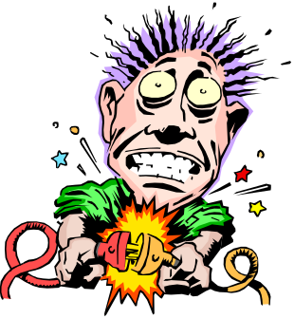
Electricity Revision Sheet 3

- In your own words describe electrical:

  - Current:

  - Voltage:

  - Resistance:

- What are each of these measured in:

  - Current:

  - Voltage:

  - Resistance:

- If the Voltage did not change but the Resistance got bigger what would happen to the Current?

- Calculate the missing numbers in these situations:

  - Car horn:
    - Voltage: 12 Volts
    - Resistance: 24 Ohms
    - Current: ____ Amps

  - Car starter motor:
    - Voltage: 12 Volts
    - Resistance: ____ Ohms
    - Current: 48 Amps

  - Generator:
    - Voltage: ___ Volts
    - Resistance: 10 Ohms
    - Current: 24 Amps

  - Fridge:
    - Voltage: 240 Volts
    - Resistance: ____ Ohms
    - Current: 2 Amps

- How do objects get static charges? What happens when they discharge?

- Describe the energy transfers for the following:

  - Light bulb:

  - Radio:

  - Kettle:

  - Hairdryer:

- Why are parallel circuits better than series circuits? (2 reasons)

- What is needed for a complete active circuit?

- Draw an electrical diagram showing a single circuit with a light bulb, switch, battery and wires. Use the correct electrical symbols.

- What things do you need to make:

  - A very simple battery?

  - An electromagnet?

- List 4 sensible electrical safety rules for the home:

- The following things make electricity safer to use in the home. Describe how each works.

  - A fuse:

  - An earth wire and pin:

c. Insulated coatings around the wires:

